

**Office of the provost**

**Request for Proposals:**

**Provost’s Interdisciplinary Teaching Awards**

**RFP Due Date: April 22, 2019**

The Office of the Provost is pleased to announce the Provost’s Interdisciplinary Teaching Awards (ITA) Program. Emerging from the deliberations of the Provost’s Interdisciplinary Working Group, the program is designed to encourage and support faculty interested in creating new courses, or redesigning existing ones, that cut across the boundaries of departments and schools. It aims to spur faculty collaboration across disciplines and advance innovative interdisciplinary education and inquiry. The ITA program will award grants to teams of faculty members from different departments or schools to collaborate on the development and teaching of undergraduate or graduate courses.

**What kinds of proposals are candidates for ITA funding?**

Proposals should present plans to design or redesign an undergraduate or graduate course that integrates content and perspectives from different disciplines to enhance student learning. Proposals must involve faculty from two or more departments or schools and may be in collaboration with centers or institutes. Proposals are welcome from all departments and schools at Columbia, as are all disciplines and subject areas.

Successful proposals will:

* Demonstrate thoughtful interdisciplinary faculty collaboration, involving two or more instructors from different disciplines;
* Propose innovative approaches to teaching interdisciplinary concepts and methods that have the potential to be more impactful on student learning than more traditional, disciplinary approaches;
* Describe the targeted undergraduate and/or graduate student cohort, likelihood of attracting students, and expected class size;
* Include appropriate learning goals and methods of assessing student learning;
* Specify the programs in which this would be offered as an elective or required course;
* Have the potential to become sustainable;
* Provide realistic budgets that effectively leverage available funding.

**Who is eligible to apply?**

Full-time and part-time faculty. Visiting faculty are not eligible. Each award will be made to the whole team and not to any individual.

Applications must name at least two faculty members of the instructional team, with one member designated as the administrative leader. Applications may include up to three Co-PIs. The administrative leader must be prepared to assume primary administrative and financial responsibility for the project.

Faculty whose primary appointments are in Barnard or Teachers College may submit proposals, but proposals must be accompanied with letters of support from their respective provosts which confirm that financial costs of the awards will be covered by Barnard or Teachers College.

**What kind of funding is available?**

Faculty member teams are invited to apply for funding for up to $20,000 to be used for the development of a course. Awardees will also commit to teaching the course at least once over the next two years.

Funding can be used for course preparation, course content development, technology and media development costs, administrative costs, and teaching assistants/course assistants, but may not be used to pay faculty salary or stipends.

**What is required to apply?**

To be considered in this competition, proposals must be received by April 22, 2019 at 5:00pm. Interested applicants are strongly encouraged to consult with the [Center for Teaching and Learning (CTL)](https://ctl.columbia.edu/) on course design, and assistance in new pedagogies, student assessment, and course evaluation while preparing the proposal. Please contact [ColumbiaCTL+ITA@columbia.edu](mailto:ColumbiaCTL+ITA@columbia.edu) to schedule a consultation to discuss your proposal.

Applicants are required to submit proposals using an online form that will collect basic information about their proposal, including a 300 word executive summary. The last section of the form requires the following documents to be uploaded as one PDF file (in this order):

* Proposal (not to exceed 5 pages) should include:
* Title of the course
* Course catalogue description
* Description of how the course will fit into the curriculum of each related program, either as a required or an elective course
* Course goals and approaches
* Roles of each instructor
* Target audience of undergraduates and/or graduate students
* Materials to be developed
* Methods of assessing student learning
* Expected impact on student learning and on faculty teaching and development
* Evaluation criteria and methodology to gauge the effectiveness of the course in achieving its aims
* Plan for course sustainability
* Any other information to support the proposal (including citations).
* Letters of support *(required)*
  + From all relevant Deans and Department Chairs.
* Budget documents
  + Detailed budget and narrative (a budget form is included at the end of this RFP). Budget items should be listed by expense category (e.g., teaching assistants/course assistants; course content, technology, and media development; supplies and materials; etc.).
  + Description of any other funds expected or received for the development or teaching of this course.
* Implementation timeline
* Biosketch or curriculum vitae for each faculty team member.

If the proposal is funded, proper course work and academic approvals must be obtained from all appropriate committees and academic offices.

**How will proposals be reviewed?**

All awards will be made on a competitive basis. Proposals will be reviewed by a faculty committee representing a range of disciplines and schools, who will submit their recommendations to the Provost. We expect to fund up to five proposals in this round. Award amounts will be determined individually by proposal and by reviewer feedback.

**What is required of awardees?**

Faculty receiving awards are expected to provide full reporting of funds spent. Unspent funds must be returned. In addition, awardees will provide progress updates and agree to have news of their work shared on the Office of the Provost and other websites. At least two progress reports will be required: the first due on June 1, 2020, which will include the finalized course syllabus; and another due by June 1, 2021, after the first course offering, addressing the impact of the award on student learning, the classroom experience, and faculty teaching and development. Awardees may be asked to present their work at appropriate forums convened by the Provost’s Office. Awardees will update Provost’s Office staff periodically with general developments on their projects.

**Submission and Notification**

Applicants are required to submit the entire application using the online form. The deadline for submission of proposals is April 22, 2019 at 5:00pm. Awards will be announced by June 7, 2019. The link to the online form follows below:

<https://www.cognitoforms.com/ColumbiaUniversity3/InterdisciplinaryTeachingAwardsRFP>

For your reference, a preview of the budget form and online form is attached at the end of this RFP.

**Information Sessions**

The CTL will hold a town hall on February 11 from 3:00-4:30pm in Butler 213 to offer interested faculty members more information about the RFPs and the application process, and will hold a series of RFP-focused office hours on April 5, 12, and 18 from 2:00-4:00pm.

**Contacts**

For further information about the application process, please contact the Office of the Vice Provost for Academic Programs at [ovpap@columbia.edu](mailto:ovpap@columbia.edu) or 212-854-7165.

For information related to support from the Center for Teaching and Learning (CTL) on course design, and assistance in new pedagogies, student assessment, and course evaluation, please contact [ColumbiaCTL+ITA@columbia.edu](mailto:ColumbiaCTL+ITA@columbia.edu).

**Application Materials for ITA, Round 1**

**Budget Request Template p. 6**

**Preview of ITA Online Form p. 7**

**Provost’s Interdisciplinary Teaching Awards**

**Columbia University**

**Budget Request**

**RFP Due Date: April 22, 2019**

**Proposal Title:**

**Faculty Administrative Leader:**

|  |  |
| --- | --- |
| **Category** | **Overall Total** |
| Personnel (teaching assistants, course assistants; research assistance) [1] | $ 0.00 |
| Course content, technology, and media development | $ 0.00 |
| Supplies and materials | $ 0.00 |
| Administrative costs | $ 0.00 |
| Other costs (please specify)[2] | $ 0.00 |
|  | $ 0.00 |
|  | $ 0.00 |
|  | $ 0.00 |
| **Total Cost** *(cannot exceed $20,000)* | $ 0.00 |

**BUDGET NARRATIVE & JUSTIFICATION**

*Please provide a short description and justification of how funds received from the Provost’s Interdisciplinary Teaching Award will be used.*

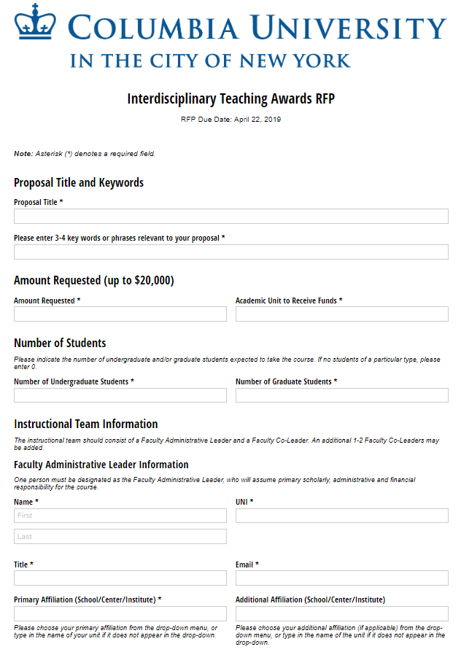

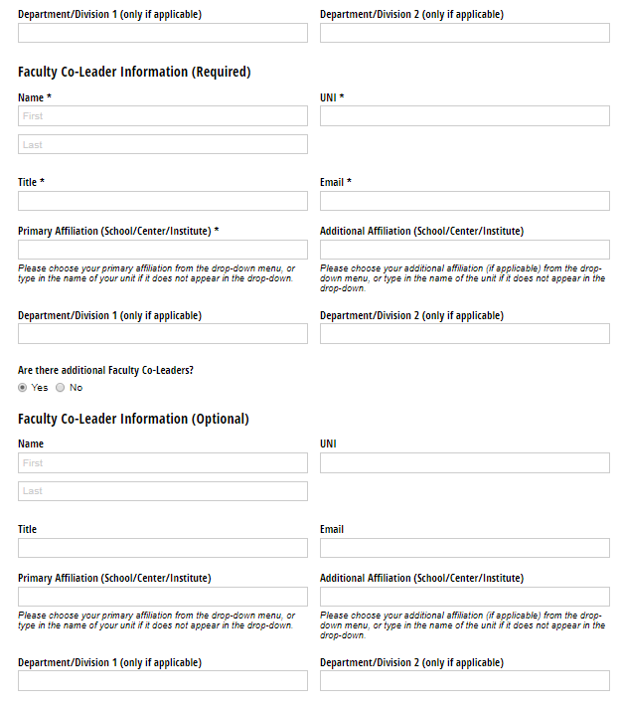

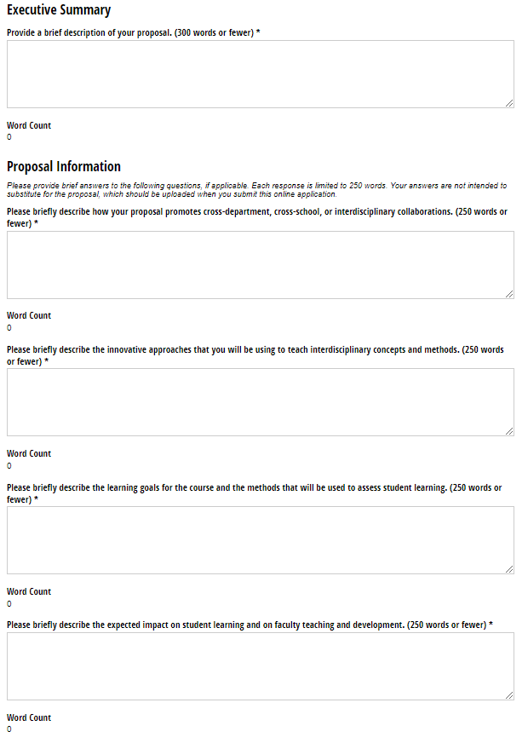

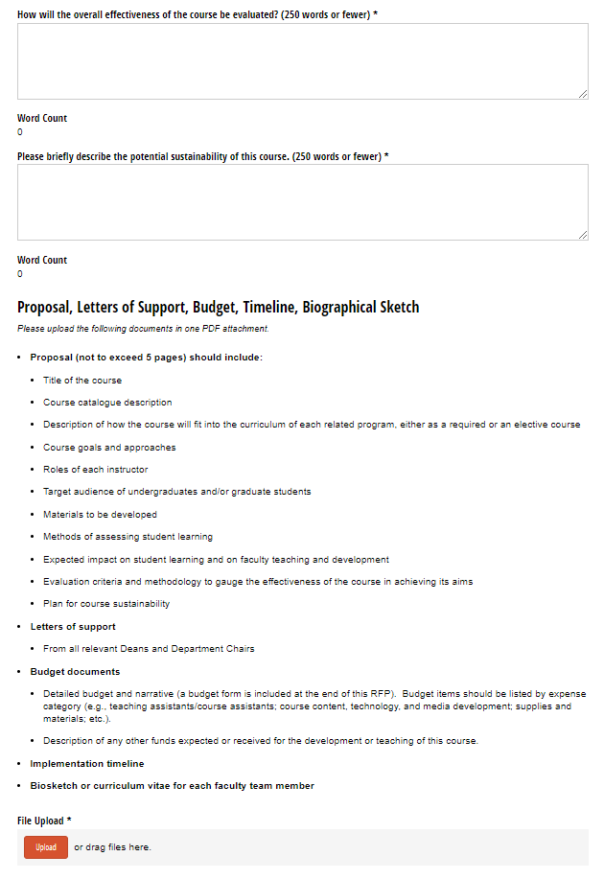

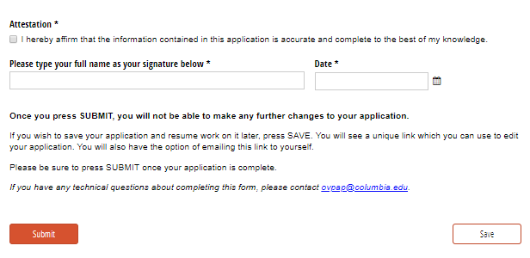

1. Grant funds may not be used to pay faculty salary or stipends.
2. Administrative fees should not be assessed on grant funds.