Request for Proposals for
President’s Global Innovation Fund
Columbia University

RFP 9 Due Date: February 1, 2022

The Columbia Global Centers are a global network of regional hubs that provide a wide range of activities and resources intended to enhance the quality of research and learning at the University. They are built on the belief that establishing an interactive network of partnerships across geographic boundaries and collaborations within and across traditional academic disciplines can help address complex challenges by bringing together scholars, students, public officials, private sector leaders, and innovators from many fields.

The Columbia Global Centers support faculty in a variety of ways. They are the bases for numerous interdisciplinary research projects, the homes of important student programming across our schools, and the catalysts for academic partnerships around the world. In many ways, they are prepared to support our faculty’s global aims, and to further their dialogue with stakeholders in the regions relevant to their research. Their presence on the ground provides agency: spurring interactions with local and regional academic communities, institutions, governments, and other partners. These interactions encourage academic reciprocity between local thinkers and the Columbia University scholarly community—espousing a global dialogue that transcends geographic, economic, cultural, and social barriers. By virtue of their interdisciplinary outreach, the network of Centers encourages new relationships across schools, institutes, and academic departments at the University. Their decentralized nature allows for collaboration and programming across the network of nine Centers—enabling research projects and initiatives that are global in scope and that address the central concerns and challenges of our globalizing societies. The Centers also provide critical logistical support and hosting mechanisms, including the use of their own facilities or access to appropriate facilities in the Center’s city or other cities served by the Center.

Launched in 2013, the President’s Global Innovation Fund awards grants for faculty members to leverage and engage Columbia’s network of Global Centers. Over the past eight rounds, a total of 109 proposals, representing faculty across nearly all of Columbia schools, received awards. The program functions as a venture fund that enables the development of projects and research collaborations within and across these sites, in order to increase global opportunities for research, teaching, and service. Projects must engage one or more of Columbia’s Global Centers (Amman, Jordan; Beijing, China; Istanbul, Turkey; Mumbai, India; Nairobi, Kenya; Paris, France; Rio de Janeiro, Brazil; Santiago, Chile; and Tunis, Tunisia). Projects may be based in a city where a Columbia Global Center is located, or in other locations in the regions served by a Global Center. Leveraging the Global Centers will enable the Centers and their staff to go beyond their operational capacity—often providing support, counsel, and a network of contacts to concretize and supplement existing research and programming goals. The Centers are a conduit to local, regional, and global knowledge, expertise, and networks, and they should be utilized as such.

An overview of Columbia Global Centers, including descriptions of local, regional, and international partnerships, programming, and projects; Center interests, priorities, and thematic focus; and Center personnel and space, can be accessed here.

This year, we are excited to announce that this call for proposals will be aligned with three thematic areas that support the interdisciplinary initiatives of critical importance to the university. These three thematic areas -- Climate and Sustainability, Health and Medicine, and Social Justice and Equity – are aimed at
tackling the most pressing societal challenges while building upon interdisciplinary strength across schools, institutes and centers.

What kinds of projects are candidates for funding?

Successful project proposals will go beyond a standard individual investigator research project: demonstrating cooperative and equitable research partnerships with local and regional stakeholders; building national and regional research capacity; and providing opportunities for students to engage in meaningful partnerships with faculty in research, education, or training. They will also integrate one or more of the three university-wide themes described above: Climate and Sustainability, Health and Medicine, and Social Justice and Equity

Eligible project types could include:
- Support for the development/implementation of educational or curricular initiatives at the graduate or undergraduate level (new courses and seminars or fieldwork/travel components of campus-based courses; training or group workshop/internship programs with local partners).
- Support for research collaborations: pilot research projects; linkages with local universities, NGOs, and/or government agencies.
- Scholarly events (conferences, workshops, symposia) in collaboration with local scholars/scientists, and/or institutions/organizations.

Projects will be evaluated on the thoughtfulness and feasibility of their proposed research or educational experience. Applications proposing to work with multiple Centers must make clear how these collaborations will advance the work; proposing multiple collaborations without justification will not advantage the proposal.

Special consideration will be given to those projects which:
- Provide opportunities to students to engage and partner meaningfully with faculty in research, education, or training.
- Forge collaborations with local researchers, educators, and institutions.
- Promote cross-school or interdisciplinary faculty collaborations.
- Provide realistic budgets that effectively leverage the funding available.
- Have the potential to attract external support; or seek matching funding opportunities.
- Have the potential to grow into sustainable programs.

Who is eligible to apply?

Those eligible to apply are: faculty members with full-time professorial titles, modified or unmodified; instructors; and professional officers of research (senior research scientists/scholars; research scientists/scholars; associate research scientists/scholars). Lecturers are not eligible to apply. Applications must designate a Contact PI; they may include up to two Co-PIs. Additional collaborating Columbia faculty may be listed. The Contact PI must be prepared to assume primary scholarly, administrative, and financial responsibility for the project.

Faculty whose primary appointments are in Barnard or Teachers College may submit applications, but proposals must be accompanied with letters of support from their respective provosts which confirm that financial costs of the awards will be covered by Barnard or Teachers College.

What kind of funding is available?

All awards will be made on a competitive basis. Award amounts will be determined individually by project. The funding of a planning grant does not in any way guarantee the automatic funding of a future project grant. We invite two types of proposals:

- Planning grants (up to $20,000), for a period of no longer than one year.
- Project grants (up to $30,000 per year), for a period of up to two years, and capped at $50,000 for the entire project. Two-year grants will be reviewed and renewed annually, pending adequate progress.

What is required to apply for funds?

To be considered in this competition, applications for funds must be received by February 1, 2022.

In developing proposals and budgets, applicants are required to consult with the director(s) of the relevant Global Center(s) about project feasibility and engagement with the Center, prior to submission, to assess feasibility.

Applicants with projects that include student travel are required to consult with Columbia’s Office of Global Programs (for programs that involve undergraduate students) or the Dean of Students of the associated school (for programs that involve graduate students). If the project is funded, please note that proper approvals from all committees and academic offices will need to be obtained for projects that involve course work or academic credit.

Although no letter of support is required, principal investigators must inform their Dean of their application. Letters of support from Co-PIs and collaborating faculty, describing their role in the project and commitment to completing the proposed work, are required. Other letters of support, such as those from external collaborators, institutions, and funders, may be included.

Applicants are required to submit proposals using an online form that will collect basic information about their proposal, including a 300-word executive summary. The last section of the form requires the following documents to be uploaded as one PDF file (in this order):

- Budget documents
  - Detailed budget and narrative (a budget sheet is included at the end of this RFP). Budget items should be listed by expense category (e.g., travel, research or education costs, materials production). Note that the budget should not include costs associated with the Global Centers (e.g., facility rental, administrative support provided by the Global Center).
  - Description of any other funds expected or received for this project.
- Proposal (not to exceed 5 pages) describing the project, goals and approaches, the nature of collaboration with relevant Global Centers, proposed partners and participants, inclusion of undergraduates and/or graduate students (and to what extent), and expected impact.
- Letters of support (required)
  - From Co-PIs and collaborating faculty, describing their role in the project and commitment to completing the proposed work.
- Letters of support (as appropriate)
  - From external collaborators, other institutions, or other investigators.
  - From other external funding sources.
- Principal Investigator’s biographical sketch (not to exceed 5 pages).

How will proposals be reviewed?

Proposals will be reviewed by a committee of faculty representing a range of disciplines and schools, who will submit the results of their review to the Provost. The Provost will make a final recommendation to the President.

PGIF funds are very competitive, and in the past, the RFP has resulted in many more outstanding applications than could be supported. While we cannot predict the number of awards which will be made in this round, roughly 25-30% of the applications submitted in the first eight RFP cycles received some level of funding.

What is required of grantees?

Faculty receiving awards will be expected to provide full reporting of funds spent. Unspent funds must be returned.

In addition, fund recipients will provide progress updates and agree to have news of their work shared via external communications, such as the Columbia Global Centers website and the Columbia Global platform, or other press releases and publications, and to present their work at appropriate forums such as the Columbia Global Centers Annual Directors’ Summit on campus. PIs will update Global Center staff periodically, highlighting upcoming conferences, visits to the regions, and general developments on their projects.

Submission

Applicants are required to submit the entire application using the online form by February 1, 2022. The link to the online form follows below:
https://www.cognitoforms.com/ColumbiaUniversity3/requestforproposalsround9

For your reference, a preview of the online form as well as a template for the budget request is attached at the end of this RFP.

Contacts

Overviews of each Global Center and contact information for each Center Director can be accessed in the appendix. For further information related to the Columbia Global Centers, please contact: Ahmad Al-Mousa, aam250@columbia.edu.

For further information about the application process, please contact ovpap@columbia.edu

Information on past projects, and overviews of each of the Global Centers can be accessed at the President’s Global Innovation Fund website.

Application Materials for
President’s Global Innovation Fund, Round 9

Budget Request Template p.6

Preview of President’s Global Innovation Fund Online Form p.7
President’s Global Innovation Fund
Columbia University
Budget Request

RFP Due Date: February 1, 2022

Project Title:

Principal Investigator:

Type of Application:
___ Planning Grant
___ Project Grant

BUDGET
Please provide a summary budget of the proposed project. Add lines or categories as necessary.
Personnel, including salary and fringe (research assistance) | $ 0.00
Supplies and materials | $ 0.00
Meetings and travel (air fare, hotel) | $ 0.00
Other costs (please specify) | $ 0.00
 | $ 0.00
 | $ 0.00
 | $ 0.00
Total Year 1 Costs | $ 0.00
Total Year 2 Costs | $ 0.00
Total Cost | $ 0.00

BUDGET NARRATIVE & JUSTIFICATION
Please provide a short description and justification of how funds received from the President’s Global Innovation Fund will be used.

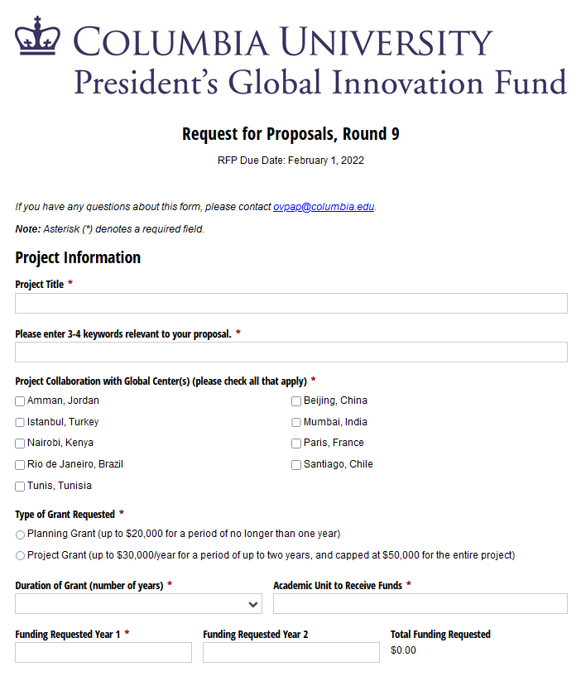

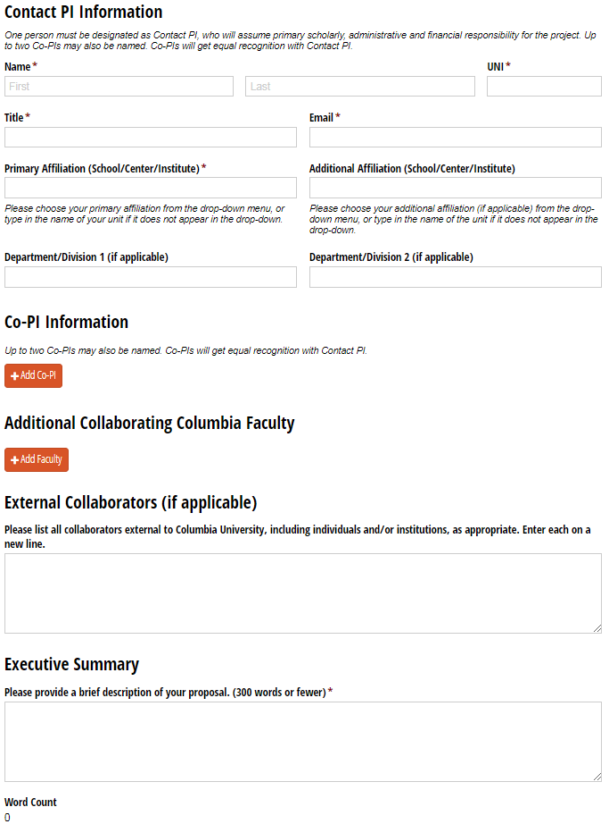

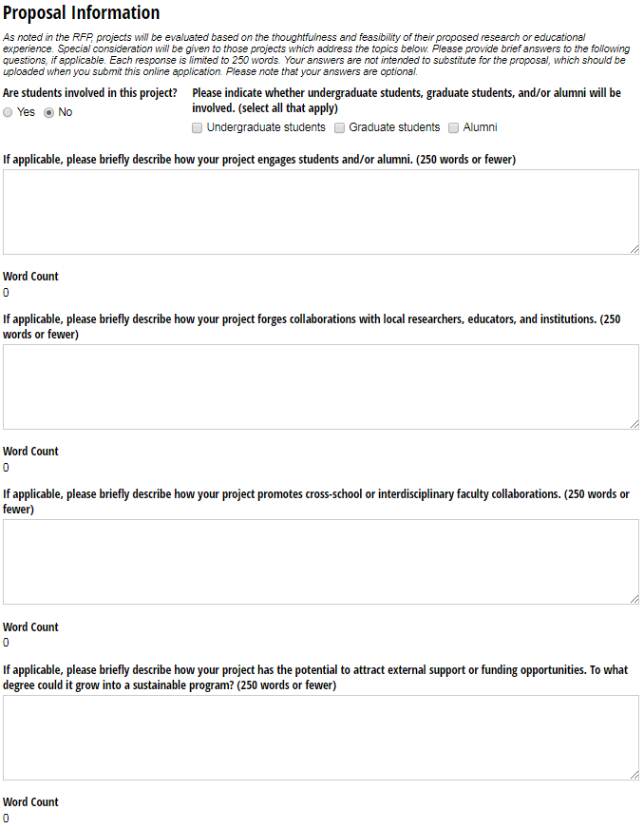

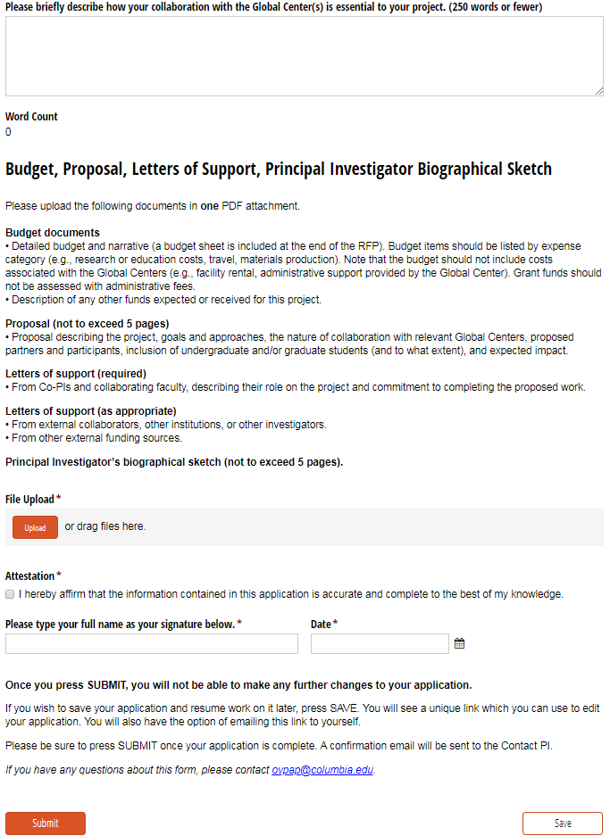

Do not include costs associated with the Global Centers (e.g., facility rental, administrative support provided by the Global Center).
Grant funds should not be assessed administrative fees.

